**Android Project: Service Novigrad**

**SEG2105 – Introduction to Software Engineering**

**Fall 2020**

­­­

Student name: Gary Gao

Student number: 300124236

Brief Introduction:

This application will implement basic functionality for services offered by an imaginary province called Novigrad to its residents. It will provide services (like driver’s license, health card, photo id) for users to register and assign a branch to a user.

It will include three roles, the administrator, the user and branch/employee. The administer can administrate all the employee and the services all the employee can provide. The branch account can approve or reject a service request by the user, it can decide which of the services it can provide and lastly, it can decide its working hour. The user can register and request for service at a branch.

Roles in my group:

For deliverable 4 and “deliverable 2&3 folder”, I did them alone with nobody’s help. For deliverable 1, my team worked together.

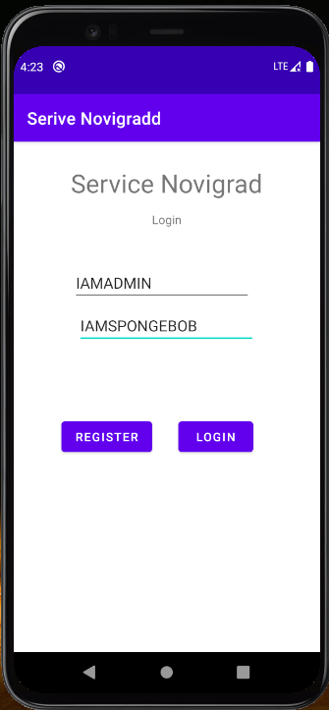Screen Shots:

User Login Admin AdminServices

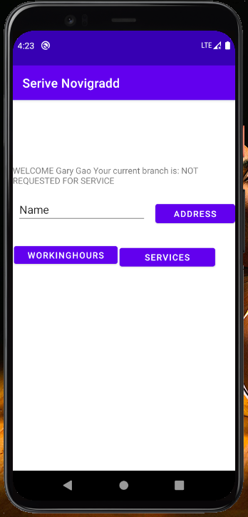

<-

Register

User Login

->

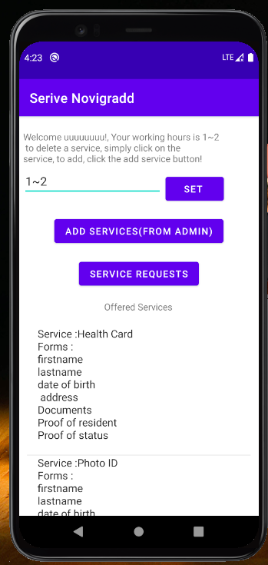

Branch

Login

<-

Add More

Service

->

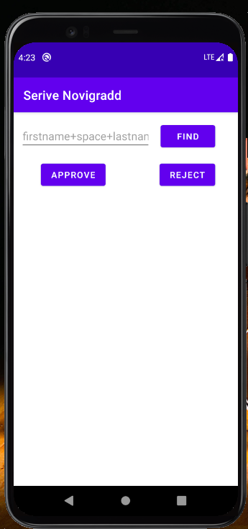

Approve/reject user’s service request

Lesson Learned:

There is so much I learned in this project, as the Professor said, the purpose of this project is to push us out of our comfort zones. In this project, I tried to put in everything I learned in the lab. Buttons, listviews, EditTexts, different activities and way more.

I review and learned more about Android studio, I got to use a database in a real project for the first time, I did not know any good way to store data and now I know. I tried to use arraylist and hashtable for the first time. Now, everything I wrote in my program I know exactly how they work and what they are for, I got to know the basics to build a software. I will try to upgrade this software later on as I learn more.